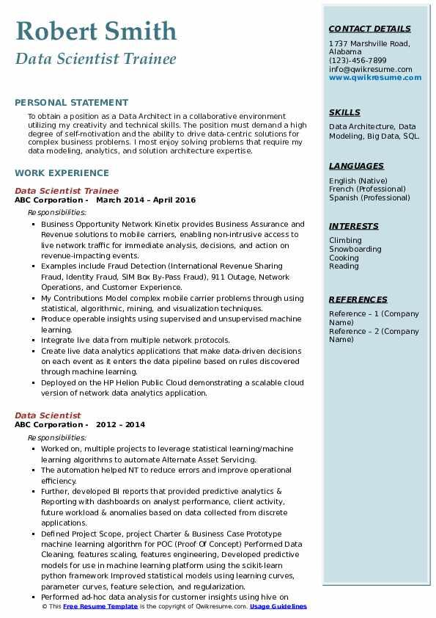
Robert Smith
Data Scientist Trainee
CONTACT DETAILS
1737 Marshville Road, Alabama
(123)-456-7899
info@qwikresume.com www.qwikresume.com
PERSONAL STATEMENT
To obtain a position as a Data Architect in a collaborative environment utilizing my creativity and technical skills. The position must demand a high degree of self-motivation and the ability to drive data-centric solutions for complex business problems. I most enjoy solving problems that require my data modeling, analytics, and solution architecture expertise.
WORK EXPERIENCE
Data Scientist Trainee
ABC Corporation March 2014 - April 2016
Responsibilities:
• Business Opportunity Network Kinetix provides Business Assurance and Revenue solutions to mobile carriers, enabling non-intrusive access to live network traffic for immediate analysis, decisions, and action on revenue-impacting events.
Examples include Fraud Detection (International Revenue Sharing Fraud, Identity Fraud, SIM Box By-Pass Fraud), 911 Outage, Network Operations, and Customer Experience.
My Contributions Model complex mobile carrier problems through using statistical, algorithmic, mining, and visualization techniques.
• Produce operable insights using supervised and unsupervised machine learning.
⚫ Integrate live data from multiple network protocols.
Create live data analytics applications that make data-driven decisions on each event as it enters the data pipeline based on rules discovered through machine learning.
Deployed on the HP Helion Public Cloud demonstrating a scalable cloud version of network data analytics application.
Data Scientist
ABC Corporation - 2012-2014
Responsibilities:
• Worked on, multiple projects to leverage statistical learning/machine learning algorithms to automate Alternate Asset Servicing.
The automation helped NT to reduce errors and improve operational efficiency.
Further, developed BI reports that provided predictive analytics & Reporting with dashboards on analyst performance, client activity, future workload & anomalies based on data collected from discrete applications.
• Defined Project Scope, project Charter & Business Case Prototype machine learning algorithm for POC (Proof Of Concept) Performed Data Cleaning, features scaling, features engineering, Developed predictive models for use in machine learning platform using the scikit-learn python framework Improved statistical models using learning curves, parameter curves, feature selection, and regularization.
• Performed ad-hoc data analysis for customer insights using hive on © This Free Resume Template is the copyright of Qwikresume.com. Usage Guidelines
SKILLS
Data Architecture, Data Modeling, Big Data, SQL.
LANGUAGES
English (Native) French (Professional) Spanish (Professional)
INTERESTS
Climbing Snowboarding Cooking Reading
REFERENCES
Reference - 1 (Company
Name) Reference - 2 (Company
Name)

